PHASE 01
Write a short explanation of why the response changes when /1, /2, and /3 are used.
Ans
The response change because we changed the http request by changing /1 , /2 which caused the browser to access different endpoint through api and hence server response was unique for each endpoint

Communication diagram

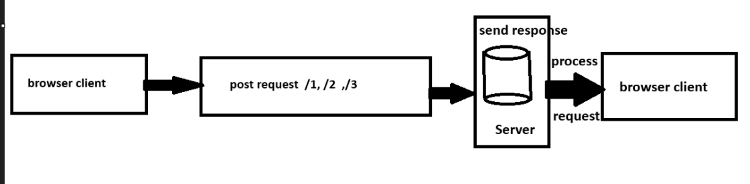

when the browser requests posts 1 it sends a request to the api which forwards it to the server the server retrieves the data for post 1 and sends it back as a json response which the browser displays to the user

For each endpoint, identify:
Endpoint | Resource | Specific Resource?
/posts | posts______ | NO__________
/posts/1 | posts_____ | Object with id 1
/posts/2 | posts______ | Object with id 2

PHASE 02
No.
1 | Protocol | https
2 | Host | api.example.com
3 | Path | /students/101
4 | Resource | /students
5 | Resource identifier | /101

Operation | HTTP Method | Endpoint
Retrieve all students | get______ | /students______
Create a student | post______ | /students______
Retrieve student 101 | get______ | /students______
Update student 101 | put______ | /students/101______
Delete student 101 | delete______ | /students/101______
different http methods are used to distinguish between user requests
https://jsonplaceholder.typicode.com/posts/1
{
"userId": 1,
"id": 1,
"title": "sunt aut facere repellat provident occaecati excepturi optio reprehenderit",
"body": "quia et suscipit\nsuscipit recusandae consequuntur expedita et cum\nreprehenderit molestiae ut ut quas totam\nnostrum rerum est autem sunt rem eveniet architecto"
}

https://jsonplaceholder.typicode.com/posts/2
{
"userId": 1,
"id": 2,
"title": "qui est esse",
"body": "est rerum tempore vitae\nsequi sint nihil reprehenderit dolor beatae ea dolores neque\nfugiat blanditiis voluptate porro vel nihil molestiae ut reiciendis\nqui aperiam non debitis possimus qui neque nisi nulla"
}

https://jsonplaceholder.typicode.com/posts/3
{
"userId": 1,
"id": 3,
"title": "ea molestias quasi exercitationem repellat qui ipsa sit aut",
"body": "et iusto sed quo iure\nvoluptatem occaecati omnis eligendi aut ad\nvoluptatem doloribus vel accusantium quis pariatur\nmolestiae porro eius odio et labore et velit aut"
}

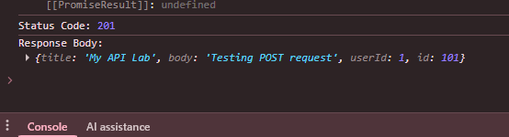

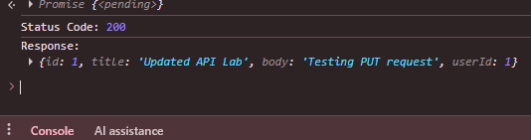

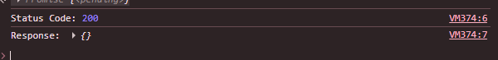

Status Code | Meaning | Your Test
200 | request successful | GET /posts/1
201 | resource created successfully | POST /posts
404 | Not Found resource does not exist | GET /posts/103

